**Exp 1 OC SC**

**Aim:** To perform open circuit (O.C.) test and short circuit (S.C.) test on single phase transformer

**Theory:**

Transformer is basically an electromagnetic device used to transform power from one operating voltage level to another level without changing frequency. The performance of a transformer is decided by parameters: - Efficiency and Regulation.

Efficiency: - Due to various losses taking place in transformer, the power output of the transformer is always less than the power input. The ratio of power output to power input is defined as efficiency.

Regulation: - Due to internal impedance of the transformer (winding impedances) the load voltage starts falling down as the load increases. The change in terminal voltage from no load to full load is defined as Regulation.

O.C & S.C. test is commonly used for testing of transformer due to following reasons

1. It is an indirect method of testing as test is carried out without actually loading the transformer.

2. It requires very low power for conduction of test.

3. the test results are comparable with direct loading test.

**Equivalent Circuit:**

Analysis of transformer performance can be conveniently made by using its equivalent circuit. An equivalent circuit of transformer is that circuit whose behaviour is very similar to that the transformer



**Open Circuit Test:**

The secondary of the transformer is normally kept open circuited and primary is being given the rated voltage. The main objective of this test is to determine the shunt branch parameters of the equivalent circuit of the transformer. As the no load current Io is small, terminal voltage V1 can be considered as induced emf E1. Thus, by neglecting copper losses, with this approximation, the power input gives core (iron) losses.

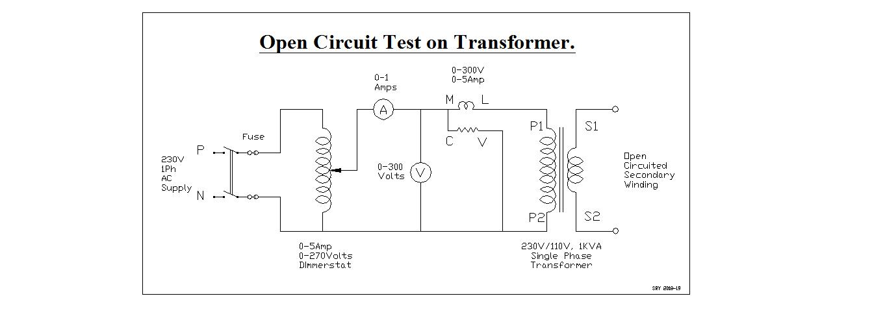

**Short Circuit Test:**

In this test the transformer is excited from high voltage side and low voltage side is short circuited. This facilitates the low current measurement of high voltage side. The main objective of this test is to determine the series parameters of the equivalent circuit.

Since the transformer resistance and leakage reactance are very small the voltage Vsc needed to circulate the full load current under short circuit is 5-8% of the rated voltage. As applied voltage is very small and iron losses are proportional to applied voltage, iron losses are neglected. The wattmeter gives the full load copper losses.

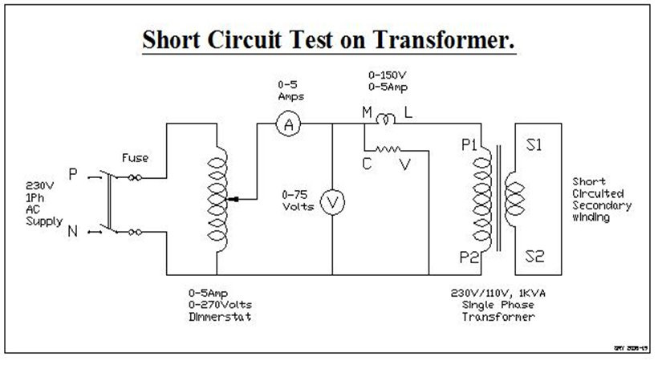

**Transformer Losses:**

When the practical transformer transfers the energy from one circuit to another circuit, some energy is always lost in this process. There are two types of power losses in transformer.

(i) Copper Loss:

It is due to resistance of the windings (both primary and secondary) and the current flowing through it. It is proportional to square of the current.

(ii) Core loss:

It occurs in the cores of the transformer and is due to alternating flux. It is not dependent on the load. It is also called as constant losses or iron losses. This loss comprises of Hysteresis loss and Eddy Current Loss.

Hysteresis loss: - This loss takes place in the transformer core because it is continuously subjected to rapid reversals of magnetization/sec by alternating flux.

**(1)O.C. test**

Core losses Wo = watts.

No load power factor (coso) = Wo/VoIo

Core loss component of the no load current

Ic = Io coso

Magnetizing component of the no load current

Im = Io sin $∅o$

Ro = Vo/Ic = ____Ω

Xo = Vo/Im = ____ Ω

**(2) S.C. test =**

Copper losses = Wsc

S.C. power factor = cossc =

Equivalent resistance referred to the primary

$R_{01}$ = $\frac{Wsc}{(I^{2 }sc)}$

Equivalent Impedance referred to the primary

$Z_{01}$ = = $\frac{Vsc}{Isc}$

Equivalent reactance referred to the primary

$X_{01}$ = = $\sqrt{{Z_{01}}^{2}-{R_{01}}^{2}}$

% efficiency = $\frac{n VA cos∅}{xScos∅+Wo+x^{2} Wsc }×100$

% regulation = $\frac{I1\left(R_{01}cos∅±X_{01}sin∅\right)}{V1} ×100$

+ve for lagging p.f. Where, n = fraction of loading (n =1 for full load, n =0.5 for half load

-ve for leading p.f.

I1 = 4.35 amp (full load)

I1 = 4.35/2 amp (half full load)

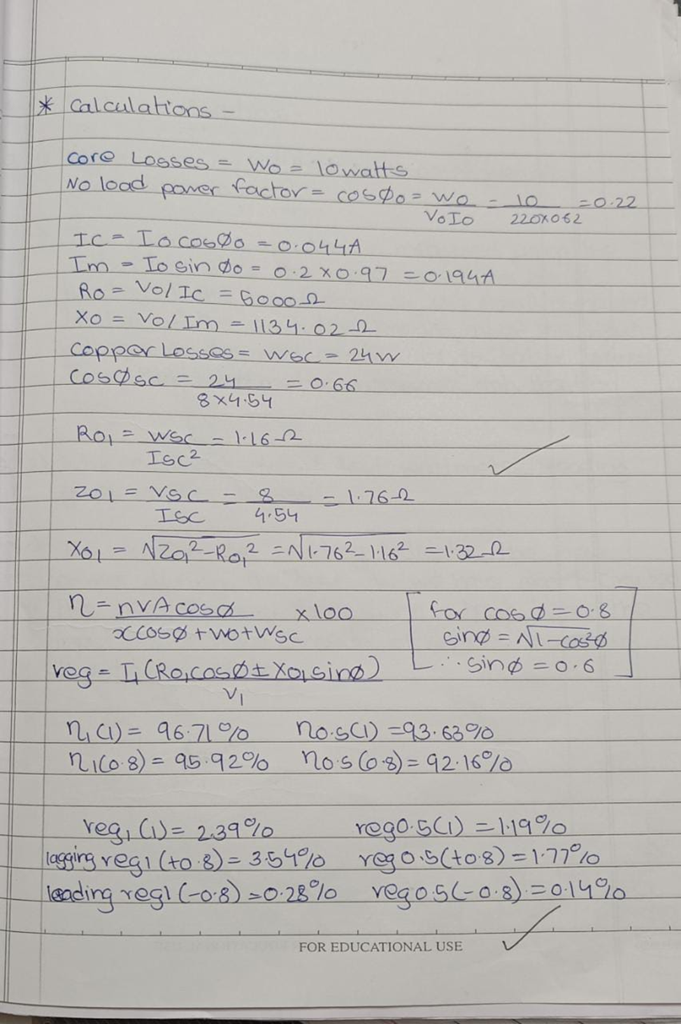

**EXP 2 Speed Control of DC Shunt Motor**

**Aim:** To observe the speed control of DC Shunt motor using Armature voltage control and Field current control method.

**Theory:**

In DC motor, as soon as the armature starts rotating, dynamically induced emf is produced in the armature conductors. The direction of this induced emf is as per the Fleming’s Right hand rule, is in direct opposition to the applied voltage. Hence it is known as back emf, Eb. Its magnitude can be calculated as,

 volts.

Where, Ф = Flux per pole in Wb

P = No. of poles

N = Speed in RPM

Z= No. of armature conductors

A = No. of parallel paths.

As P, Z and A are constant for the motor

 -----------(1)

From basic shunt motor equation

** ---------------(2)**

From equation (1) and (2)



Assuming  drop constant and Flux is proportional to field current up to saturation.



By decreasing the armature voltage motor speed decreases. This can be used to control the speed below normal speed (rated speed) of the motor. Hence this method is called as **Speed control below normal speed** of the motor.



By decreasing the field current (by weakening the flux) motor speed increases. This can be used to control the speed above normal (rated speed) of the motor. Hence this method is called as **speed control above normal speed** of the motor. (Armature voltage kept constant)



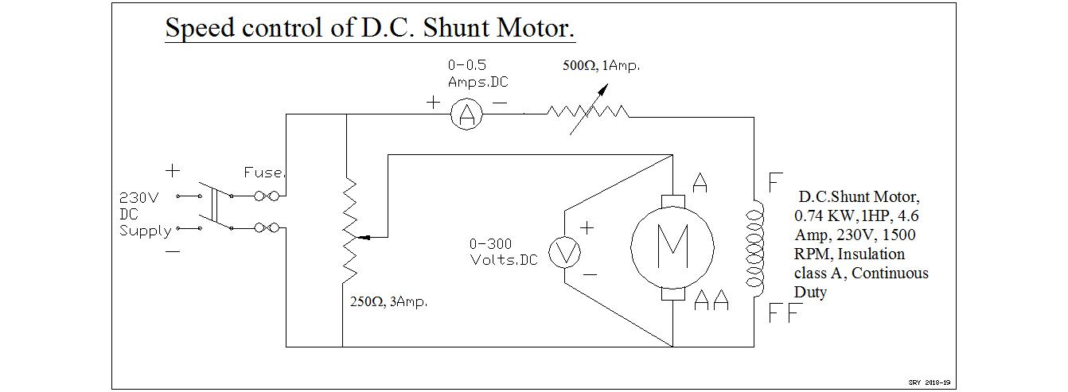

**Procedure:**

**A] Speed variation by armature voltage control**

1. Make the connections as shown in the circuit diagram.
2. Adjust the armature rheostat at minimum voltage position.
3. Adjust the field rheostat at maximum current position.
4. Apply the supply voltage and adjust the field rheostat such that field current is 0.2 Amp.
5. Slowly increase the supply voltage and note the initial reading when motor just starts running. Increase voltage in the steps of 30 volts and continue up to rated voltage 230V.
6. Keep the excitation current constant 0.2 Amp throughout the experiment.

**B] Speed variation by flux control**

1. Adjust the armature rheostat at minimum voltage position.
2. Adjust the field rheostat at maximum current position.
3. Apply the rated supply voltage 230V and obtained the rated speed of 1500 RPM by adjusting field rheostat. Note this initial reading.
4. Now by keeping armature voltage constant and by decreasing the field current in the steps of .05 amps note next four sets of readings.

Speed Vs Armature voltage Speed Vs Field current

**Exp : 3 Load test on DC shunt motor**

**Aim:** To study the performance of a D.C. shunt motor by direct loading method with the help of a braking arrangement.

**Theory:**

In one of the methods, machine is actually loaded to determine the performance. This method is called as direct loading method of testing. In the other method machine is not directly loaded to obtain performance and called indirect loading method of testing. In the brake test the motor is directly loaded by means of a belt and pulley arrangement, hence called as direct loading method of testing. The load is adjusted using belt tension to get the required load current. All the mechanical energy developed in the motor is converted into friction of the belt and pulley of the motor and hence converted in to heat. After some readings due to heat, a faster wear and tear is observed in the belt and need to replace it regularly

Torque and the power can be measured as follows.

Let, W1 and W2 = readings on the two spring balances (kg)

W = Weight applied, kg (W1 - W2)

N = Speed (rpm)

r = Radius of pulley (m)

V = Applied voltage (Volts)

I= Total motor current (Amp)

Torque =W x r x 9.81 N-m

Angular Speed ω = 2π N /60 rad/sec

Motor Output = Torque x ω watts

Motor Input = V x IL watts

$$Motor efficiency= \frac{Motor Output}{Motor Input} ×100$$

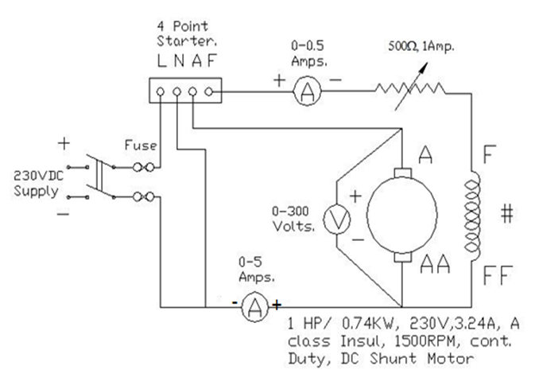

***Experimental circuit for load test on D.C. shunt motor***

**Procedure:**

1. Make the connections as shown in the circuit diagram.
2. Adjust the field rheostat at maximum current position (low resistance position).
3. Remove entire load on the motor by keeping the rope tension free.
4. Apply the supply voltage and rotate the starter handle slowly to obtain slow rising speed of the motor. Run the motor at no load.
5. Adjust the motor voltage 200 V using dimmerstat.
6. Adjust the field current such that rated speed is obtained at no load.
7. Slowly increase the tension of the belt. Adjust load current with uniform variation from no load to full load in four readings.
8. Note the readings in the observation table for every load condition.

**Graphs:**

Torque Vs Output power Current Vs .Output power

Speed Vs Output power % Efficiency Vs Output power

Speed Vs Torque

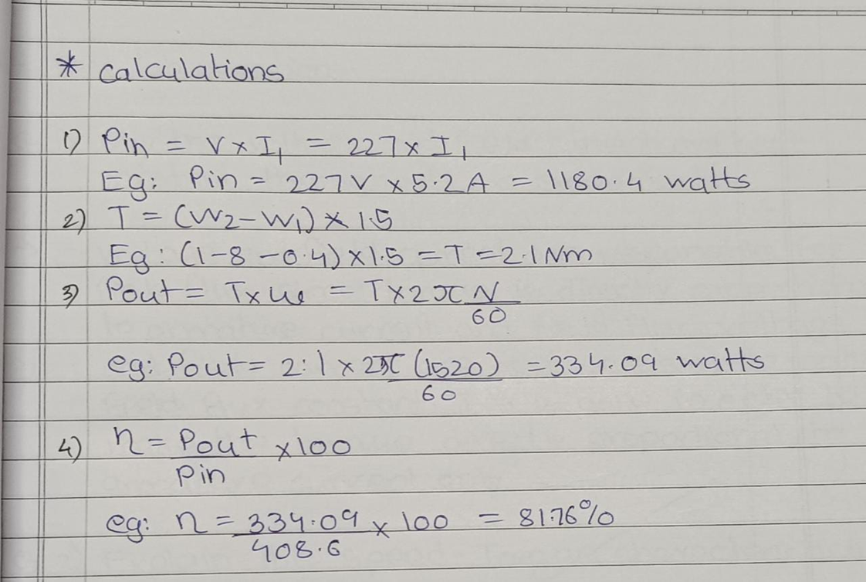

**EXP 4 Polarity test on single phase transformer.**

**Aim:** To determine the polarity of a single phase transformer

**Theory:**

**Polarity** means the direction of the induced voltages in the primary and the secondary winding of the transformer. If the two transformers are connected in parallel, then the polarity should be known for the proper connection of the transformer. There are two types of polarity one is a**dditive,** and another is **subtractive.**

In additive polarity the same terminals of the primary and the secondary windings of the transformer are connected. In subtractive polarity different terminals of the primary and secondary side of the transformer is connected.

Each of the terminals of the primary as well as the secondary winding of a transformer is alternatively positive and negative with respect to each. Let  A1 and A2 be the positive and negative terminals respectively of the transformer primary and a1, a2 are the positive and negative terminal of the secondary side of the transformer. If A1 is connected to a1 and A2 is connected to a2 that means similar terminals of the transformer are connected, then the polarity is said to be additive. If A1 is connected to a2 and A2 to a1, that means the opposite terminals are connected to each other and thus the voltmeter will read the subtractive polarity.

It is essential to know the relative polarities at any instant of the primary and the secondary terminals for making the correct connections if the transformers are to be connected in parallel or they are used in a three phase circuit.

When the voltmeter reads the difference that is (E1 – E2), the transformer is said to be connected with opposite polarity know as Subtractive polarity and when the voltmeter reads (E1 + E2), the transformer is said to have additive polarity.

**Circuit Diagram:**

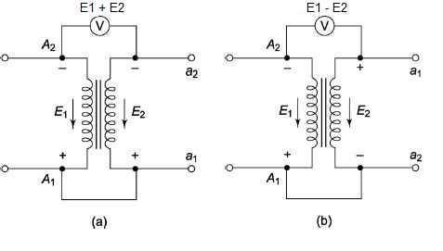

***Experimental circuit for polarity test on transformer***

**Procedure:**

1. Connect the circuit as shown in the above circuit diagram figure and set the autotransformer to zero position.
2. Switch on the single phase supply
3. Records the values of the voltages as shown by the voltmeter V1, V2 and V3.
4. If the reading of the V3 shows the addition of the value of V1 and V2 that is V2 = V1+V2 the transformer is said to be connected in additive polarity.
5. If the reading of the V3 is the subtraction of the readings of V1 and V2, then the transformer is said to be connected in subtractive polarity.

**EXP 5 Load test on three phase induction motor.**

**Aim:** To study the performance of a three phase induction motor under load conditions

**Theory:**

Load test on I.M. is used to determine speed, efficiency, power factor, stator current, torque & slip varying with load. Motor is loaded either by applying brake through belt pulley arrangement or by loading D.C. generator of known efficiency.

Speed: When I.M. is on no load, speed is slightly lower than synchronous speed. Due to induced e.m.f. in rotor winding, it produces a torque required at no load. As load increases speed is slightly reduced & e.m.f. is induced in the rotor & hence it produces a torque to match with load torque.

2) Effect on slip: Slip is expressed as difference in synchronous speed and actual speed of rotor with respect to synchronous speed. Slip is expressed as percentage of synchronous speed.

% s = $\frac{Ns-N}{Ns}$ ×100

Where, Ns = Synchronous speed

N = Rotor speed

Where synchronous speed depends upon frequency of stator supply voltage & no. of poles for which motor is wound

Ns = 120f / P

If f & P both are constant then Ns is constant of particular motor. With increase in the load the motor speed decreases then slip increases.

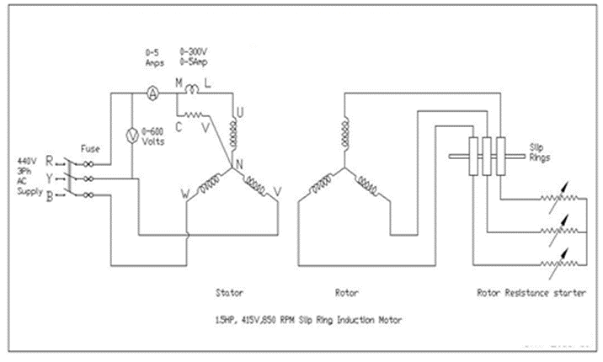

**Procedure:**

1. The connections are done as per the diagram.
2. The brake drum is kept completely free before starting the motor.
3. The rotor resistance is kept at maximum position at starting i.e. full resistance is included in the rotor circuit.
4. The motor is now started and the rotor resistance is gradually cut out.
5. No load speed, voltage, current and wattmeter readings are recorded.
6. The motor is then gradually loaded with the help of spring balances and similar readings are noted down.
7. During unloading of motor, load is gradually reduced

**Calculations:**

Let, W1 & W2 = readings on the two spring balances (kg)

W = Weight applied, kg (W1 - W2)

N = Speed (rpm)

r = Radius of pulley (m)

V = Applied voltage (Volts)

I= Total motor current (Amp)

Torque = W x r x 9.81 N-m

Angular Speed ω = 2π N /60 rad/sec

Motor Output = Torque x ω watts

Motor Input = VL x IL watts

$$Motor efficiency= \frac{Motor Output}{Motor Input} ×100$$

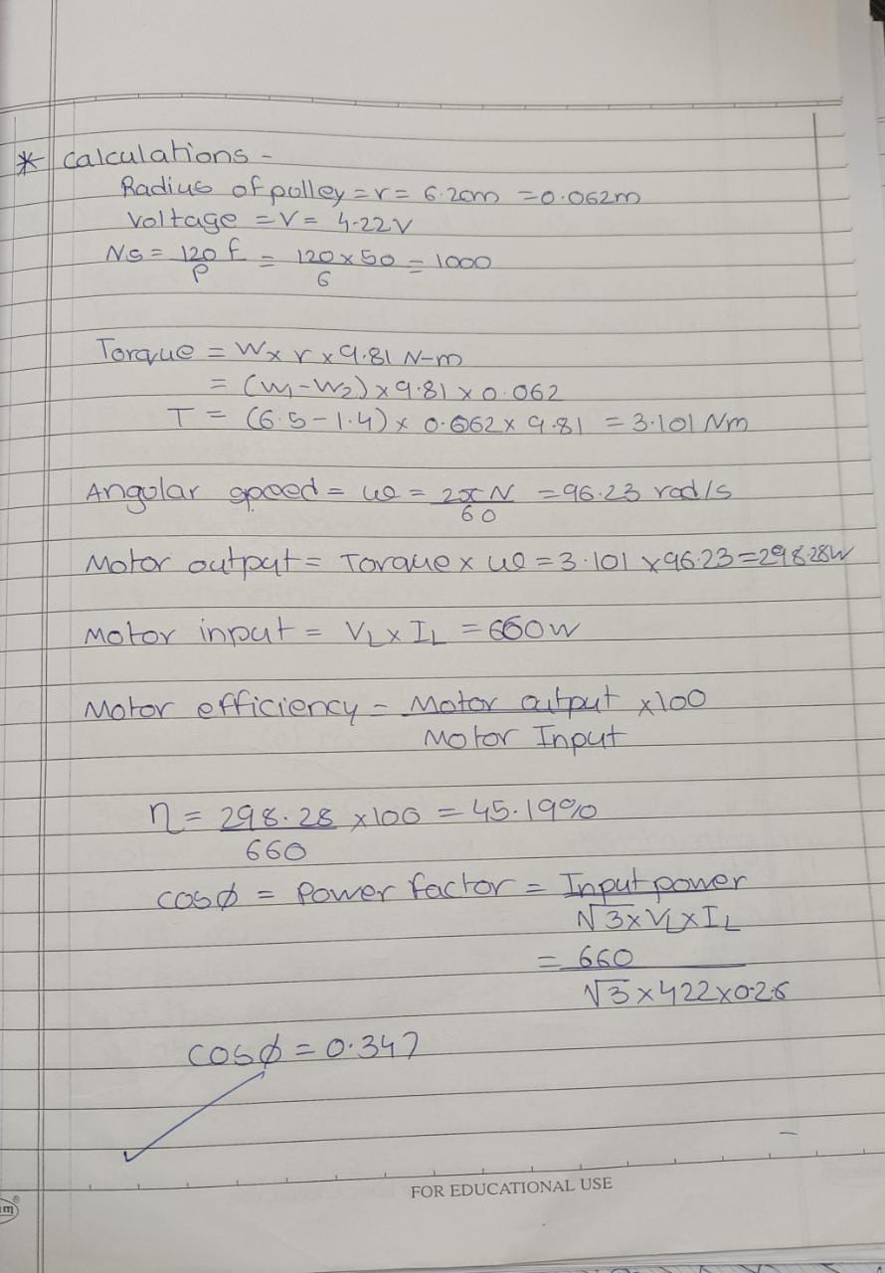

Current vs. o/p P.F vs. o/p

% η vs. o/p Torque vs. o/p

% slip vs. o/p Speed vs. o/p

**Exp no 6 : Variable frequency drive (VFD) for three phase induction motor**

**AIM:** To study the operation of a variable frequency drive (VFD) for three phase induction motor.

**VFD** is a power electronics based device which converts a basic fixed frequency, fixed [voltage](https://www.electrical4u.com/voltage-or-electric-potential-difference/) sine wave to a Variable frequency, Variable output Voltage(VVVF) used to [control speed of induction motor](https://www.electrical4u.com/speed-control-of-induction-motor-using-static-devices/)(s). It regulates the speed of a [three phase induction motor](https://www.electrical4u.com/working-principle-of-three-phase-induction-motor/) by controlling the frequency and voltage of the power supplied to the motor.

$$N_{s}=\frac{120*f}{P}$$

Any **Variable Frequency Drive** or VFD incorporates following three stages for controlling a [three phase induction motor](https://www.electrical4u.com/working-principle-of-three-phase-induction-motor/).

Its function is to control output voltage i.e. voltage vector of inverter being fed to motor and maintain a constant ratio of voltage to frequency (V/Hz). It consists of an electronic circuit which receives feedback information from the driven motor and adjusts the output voltage or frequency to the desired values. Control system may be based on SPWM (Sine Wave PWM), SVPWM (Space Vector modulated PWM) or some soft computing based algorithm

**Description of the variable frequency drive:**

**1.** **Power circuit:** The power circuit shown in Fig. 1 consists of

1. **Rectifier** : full-wave power [diode](https://www.electrical4u.com/diode-working-principle-and-types-of-diode/) based solid-state rectifier converts three-phase 50 Hz power from a standard, 440 or higher utility supply to either fixed or adjustable DC voltage. The system may include transformers for high voltage system
2. **DC link** : Capacitor for Voltage Source Inverter (VSI) Inductor for Current Source Inverter( CSI)
3. **Inverter** : Three-phase full-bridge IGBT inverter which generates a balanced three-phase variable voltage variable frequency AC supply for the three-phase induction motor.

**2.** **Control circuit:** A microprocessor-based control circuit using a sinusoidal PWM control technique provides the gate drive signals to the IGBT switches via isolated driver circuits. The switching (carrier) frequency is 4 KHz (nominal).

The control circuit of this drive does not use speed feedback. Hence speed regulation due to load changes is achieved by employing slip compensation which increases the inverter output (stator) frequency as the load torque increases so that the actual motor speed remains nearly constant.

**3. VFD front panel:** The front operating panel can be divided into three sections. The first (upper) section consists of a five digit seven segment LED display as well as polarity, status and units indication LEDs. The second (middle) section comprises of the parameter operation knob, while the third (bottom) section consists of operation, parameter operation and mode selection keys.

In the **Monitor Mode**, the drive parameters such as inverter output frequency, inverter frequency setting, motor current and voltage are displayed by accessing different sub-modes. Drive parameters cannot be changed in this mode.

In the **Block A Parameter Mode**, frequently changed drive parameters such as inverter frequency setting, acceleration/deceleration times, torque boost can be set.

In the **Block A & Block B Parameter Modes**, infrequently changed drive parameters such as motor rating, overcurrent limit, DC braking, control methods and PID controller settings can be set.

**PROCEDURE:**

1. Switch-on the drive by pressing the ‘ON’ pushbutton of the three-phase DOL (direct-on-line) starter. Adjust the supply voltage to 390V by means of the three-phase variac.
2. At power-on, the drive enters the **Monitor Mode** and the display shows ‘OFF’. The **LCL** and **Hz** LEDs will also light.
3. Press the **FWD** key. The motor will start rotating in the forward direction and accelerate to its final speed in the preset acceleration ramp time (default value is 10sec). The display, still in the **Monitor Mode**, will show the previously set output frequency (default value is 10Hz) and **FWD** LED will light
4. Press the **STOP** key. The motor will slowly decelerate to a halt in the preset deceleration ramp time (default value is 20sec) and the display will decrease to ‘0.00’. The **FWD** LED will flicker while DC dynamic braking is applied.
5. Press the **REV** key. The motor will now start rotating in the reverse direction and accelerate to its final speed in the preset acceleration ramp time. The display, still in the **Monitor Mode**, will show the previously set output frequency and **REV** LED will light.
6. Press the **STOP** key. The motor will slowly decelerate to a halt in the preset deceleration ramp time. The **REW** LED will flicker while DC dynamic braking is applied.
7. To change the motor speed, the drive output frequency has to be changed. For this, press the **RST/MOD** key once. The display enters the **Block A Parameter Mode** and the display will alternate between ‘A00-0’ and the previously set output frequency. Now press the **SET** key once. The display will show the previously set output frequency and the last digit will flicker. The digit to change can be selected by repeatedly pressing the **LCL/←** key. The frequency can now be incremented or decremented with the parameter operation knob and the motor will slowly accelerate or decelerate accordingly. To set the selected frequency, press the **SET** key. Repeatedly pressing the **RST/MOD** key will now cycle the display through the **Block B Parameter Mode**, **Block C Parameter Mode, Utility Mode** and back to **Monitor Mode**.
8. Measure the *N*/*f* (motor speed vs output frequency) characteristics, for different drive output frequencies for forward direction.

**GRAPH**

***N*/*f*** Plot the motor speed (*N* rpm) vs output frequency (*f* Hz) curve

**Exp no 7 Study of AC and DC motor starters.**

**STARTERS FOR THREE PHASE INDUCTION MOTORS.**

**Stator Impedance starter:-**

In this type of starter variable inductances or resistances are included in three lines supplying the stator of induction motor. This reduces the voltage supplied to the stator & starting current reduces to a safe value. As motor takes up speed impedance are gradually cut out. Such starter are used for high hp motors.

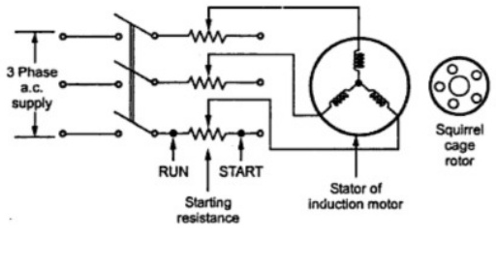

**Star delta starters**:-

This starter consists of a 3 way double throw switch which connects three phases of starter winding once in star & once in delta. In start position of the switch phases are connected in star Vph =√ 3 , reduced voltage is applied to the stator & starting remains within safe limits. When motors gets speeded switch is thrown to run position & phases get connected in delta. Full line voltage is applied across every stator phase. This starter being a simple switch is easy in construction cheaper & it is popularly used. The main disadvantage is that starting voltage can be reduces by 1/ √3 i.e. 57.7% only.

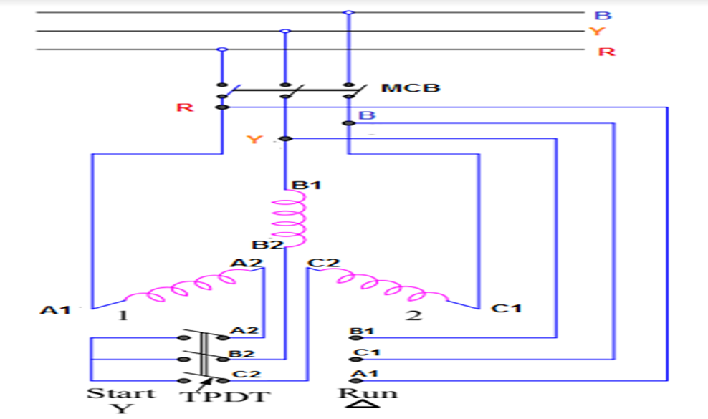

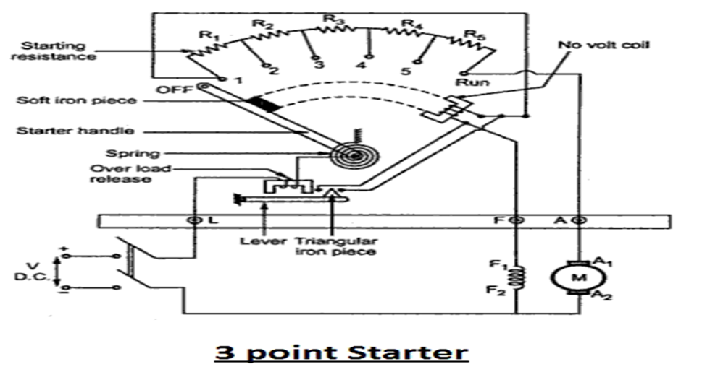**Three point starter**

It is called three-point starter because it has three terminals viz. L, Z and A. It consists of a graded starting resistance to limit the starting current and is connected in series with the armature of the motor. The tapping points of the starting resistance are taken out to a number of studs.

The three terminals L, Z and A of the starter are connected to the positive terminal, the shunt field terminal and the armature terminal respectively. The other ends of the armature and the shunt field windings are directly connected to the negative terminal of the supply.

The no-volt trip coil (NVC) is connected in shunt field circuit, which provides protection against the open circuit in the field winding. The NVC is also known as under-voltage protection of the motor. One end of the handle is connected to the terminal L through the overload trip coil (OLC) and the other end of the handle moves against the force of control spring and makes contact with each stud during the starting period of operation. The starting resistance is cutting out gradually as the handle passes over each stud in clockwise direction.

**Working Principle of Three Point Starter**

* Initially, the DC supply is switched on with handle in the OFF position.
* The handle is now moved to the first stud. When it comes in contact with the first stud, the whole starting resistance is inserted in series with the armature winding and the shunt field winding is directly connected across the DC supply.
* As the handle is gradually moved over to the final stud, the starting resistance is cut out from the armature circuit in steps. After reaching to the final stud, the handle is held magnetically by the NVC which is energized by the shunt field current.
* If the supply voltage is interrupted or if an open-circuit is occurred in the field circuit, the NVC is de-energized and the handle goes back to the OFF position under the pull of the control spring. If the NVC were not used, then in case of failure of supply, the handle would remain in contact with the final stud. When the supply is restored, the motor will be directly connected across the full supply voltage, resulting in an excessive armature current and may damage the motor.
* If the motor is overloaded or if a short circuit is occurred, it will draw a large current from the supply. This excessive current will increase the mmf of the OLC and pull the plunger P, which short-circuits the NVC. Hence, the NVC is de-energised and the handle is pulled to the OFF position by the control spring. Therefore, the motor is automatically isolated from the supply.

**Four point starter**

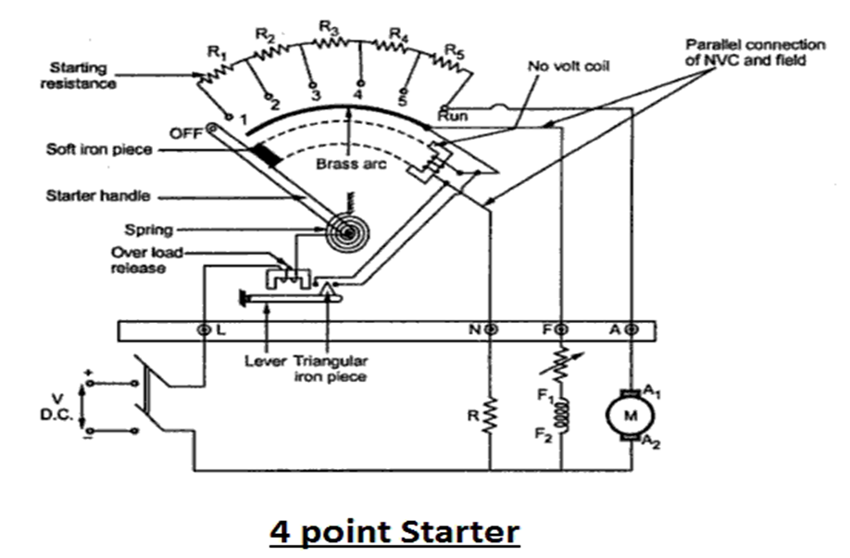

The one end of the armature coil is connected to the terminal A and of the shunt field winding to the terminal F. The other ends of the armature and the shunt field windings are directly connected to the negative terminal of the supply.

The *no-volt trip coil (NVC)* is connected directly across the line with a current limiting resistor R in series. The NVC is also known as *under-voltage protection* of the motor. One end of the handle is connected to the terminal L through the *overload trip coil (OLC)* and the other end of the handle moves against the force of control spring and makes contact with each stud during the starting period of operation. The starting resistance is cutting out gradually as the handle passes over each stud in clockwise direction.

Therefore, with this arrangement, a change in the field current for the variation of the speed of the motor does not affect the current through the NVC, as the two circuits are independent of each other.

**Working of the Four-Point Starter**

* Initially, the DC supply is switched on with handle in the OFF position.
* The handle is now moved to the first stud. When it comes in contact with the first stud, the whole starting resistance is inserted in series with the armature winding and the shunt field winding is directly connected across the DC supply
* As the handle is gradually moved over to the final stud, the starting resistance is cut out from the armature circuit in steps. After reaching to the final stud, the handle is held magnetically by the NVC which is directly energized by the DC supply.
* If the supply voltage is interrupted, the NVC is de-energized and the handle goes back to the OFF position under the pull of the control spring. If the NVC were not used, then in case of failure of supply, the handle would remain in contact with the final stud. When the supply is restored, the motor will be directly connected across the full supply voltage, resulting in an excessive armature current and may damage the motor.
* If the motor is overloaded or if a short circuit is occurred, it will draw a large current from the supply. This excessive current will increase the MMF of the OLC and pull the plunger P, which short-circuits the NVC. Hence, the NVC is de-energised and the handle is pulled to the OFF position by the control spring. Therefore, the motor is automatically disconnected from the supply.

**Exp 8 No load and blocked rotor test on three phase induction motor.**

AIM: Study of equivalent circuit parameters of 3-phase induction motor using no load & blocked-rotor test.

1. BLOCKED ROTOR TEST

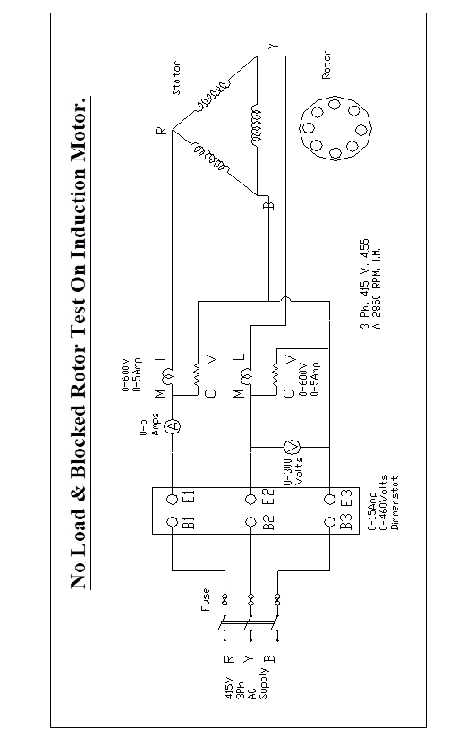Refer the fig giving the equivalent circuit of an induction motor. It has already been pointed out that at standstill(s=1) the motor impedance is [(r1+r’2)+j(x1+x’2)].

This is similar to the short circuit test on transformer. Hence the standstill conditions(obtained by holding or blocking the rotor and thus not allowing it to rotate, with reduced voltage) are like short circuit on transformer. Hence, the blocked rotor test is also termed as short circuit test. Let the voltage applied be V, the short circuit current ISC  and the power, PSC, per phase.

**CALCULATIONS: As Delta connection**

$I_{SC}\left(ph\right)=\frac{I_{SC}(line)}{\sqrt{3}}$ $V_{SC\left(Phase\right)}=V_{SC(line)}$

$Z_{01}=\frac{V_{SC} (ph)}{I_{SC}\left(ph\right)}$

$Z_{01}$ is an equivalent Impedance referred to stator

${ W_{TOT}=W}_{SC1}+W_{SC2}$

$$W_{SCph}=\frac{W_{ TOT}}{3}$$

$$W_{SCph}=I_{SC}^{2}R_{01}$$ $R_{01}$ is an equivalent resistance referred to stator

$X_{01} = \sqrt{Z_{01}^{2}-{R_{01}}^{2}}$

$X_{01}$ is an equivalent reactance referred to stator

$$Cos ∅_{sc}=\frac{W_{SCph}}{V_{SC} (ph)×I_{SC}\left(ph\right)}$$

$$Z_{01SC}=R_{01}+j X_{01}=\left(R_{1}+R_{2}^{'}\right)+j\left(X_{1}+X_{2}^{'}\right)$$

$(X_{1}+X_{2}^{'}) =\sqrt{Z^{2}sc-({R+R_{2}^{'})}^{2}}$

Further using an approximation: assume equal stator and rotor leakage reactance:

$$X_{1}=X_{2}^{'}$$

$X_{1}=X_{2}^{'}=\frac{X_{01}}{2}$

Stator resistance can be measured using multi-meter and two resistances can be separated.

1. NO LOAD TEST

In the no load test , the machine is run at no load, the slip is quite small and total rotor resistance becomes quite large. The motor is operated at the rated voltage and the stator current, voltage and power input are noted. Thus equivalent circuit then becomes as shown for no load condition. In this, it is true that the current Io flows through the stator impedance (Ro+jX0) but since no load current is quite small the circuit is acceptable. Thus from this no load test the two parameters of equivalent circuit R0 and X0 are calculated.

**CALCULATIONS :**

${I_{o}}_{\left(ph\right)}=\frac{I_{0}(line)}{\sqrt{3}}$ $V_{0\left(Ph\right)}=V_{0(line)}$ $Z_{m}=\frac{V_{SC} (ph)}{I_{SC}\left(ph\right)}$ $Cos ∅_{0}=\frac{W_{0ph}}{V_{0} (ph)×I_{0}\left(ph\right)}$ $$I_{C}=I_{O }cos∅_{o}$$ $$I_{m}=I_{O }\sin{∅o}$$ $$R_{m}=\frac{V_{O}}{I_{C}}$$ $$X_{m}=\frac{V_{O}}{I_{m}}$$